Rising demand of battery-powered vehicles for sustainable environment of Bangladesh: A review of challenges and opportunities in Bangladesh

1. Introduction

Background
Relevance
Context
Research gap
Objectives
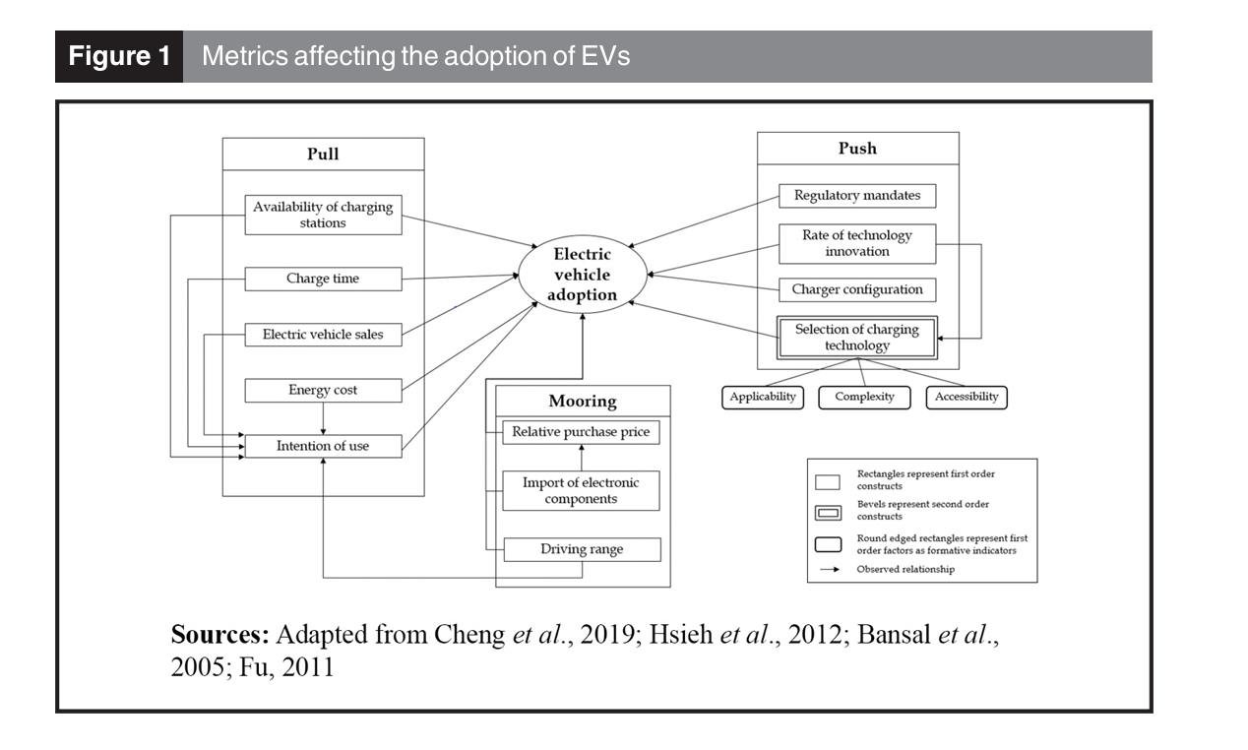
2. Review Methodology

Literature sources
Time span
Selection criteria
Screening
Contribution

3. Recent Research Trends and Saturation Analysis

Number of Publications
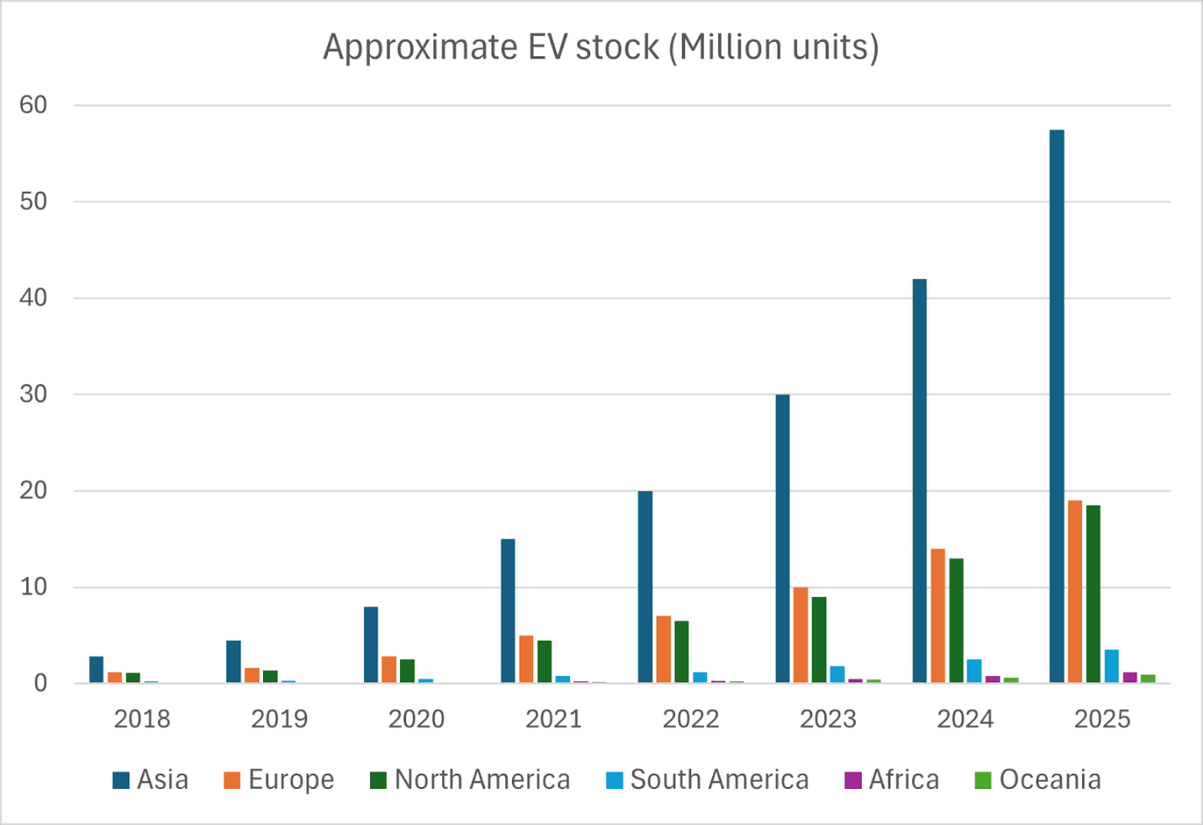

Overview of publication growth on EV
Analyze trends
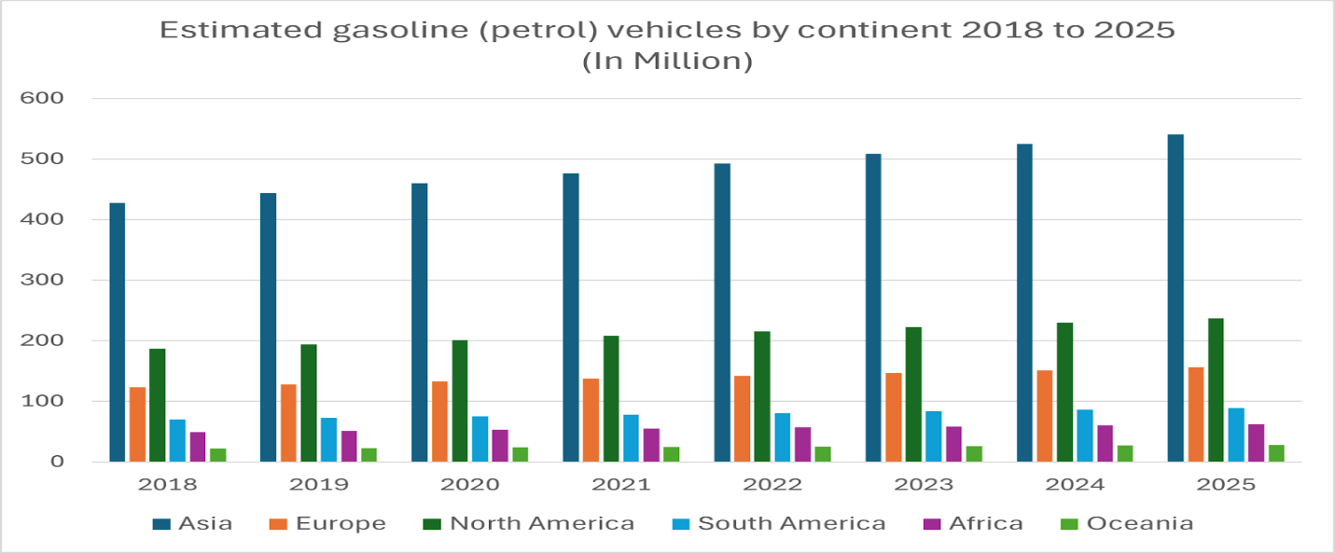
Research Summary

4. Current Scenario of Battery-Powered Vehicles

Growth trends and regional overview
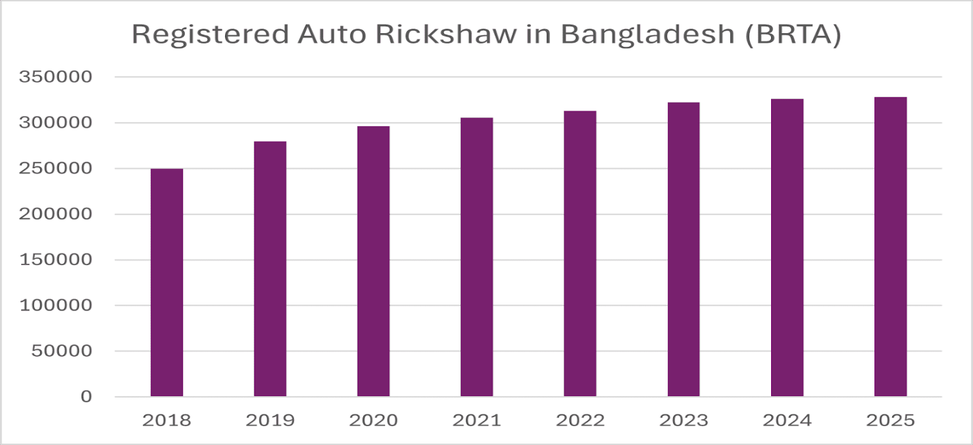
Types of vehicles
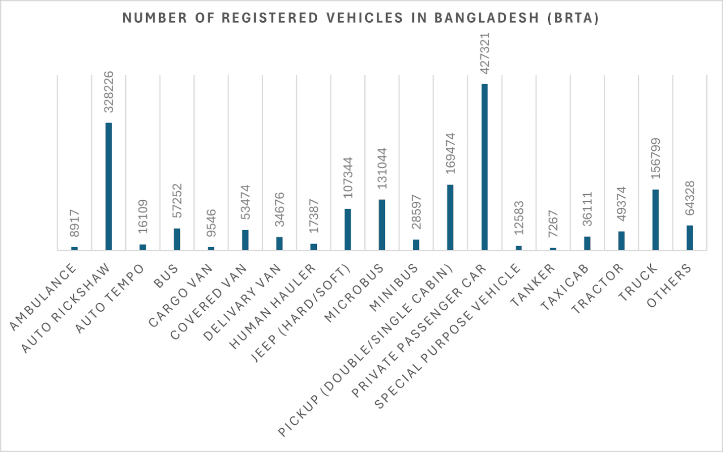
Socio-economic roles
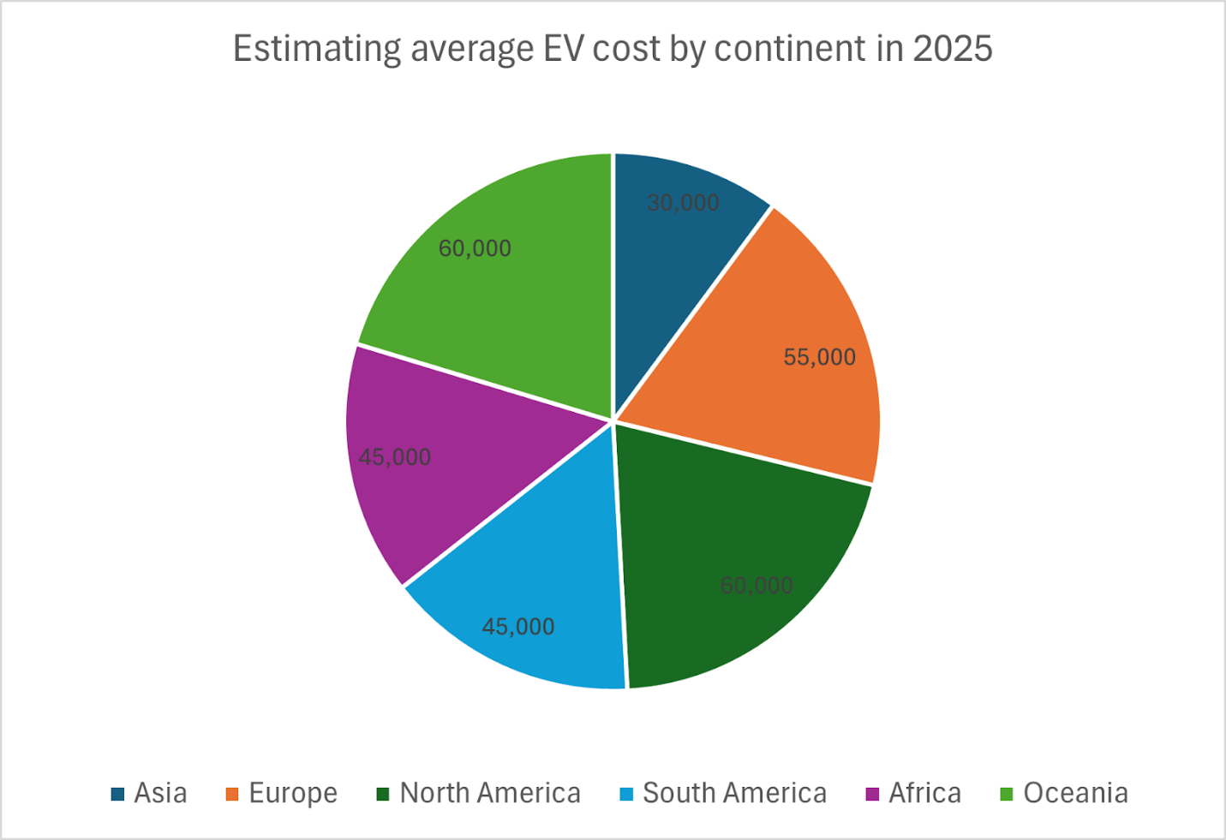
Environmental benefits
Current statistics and key stakeholders
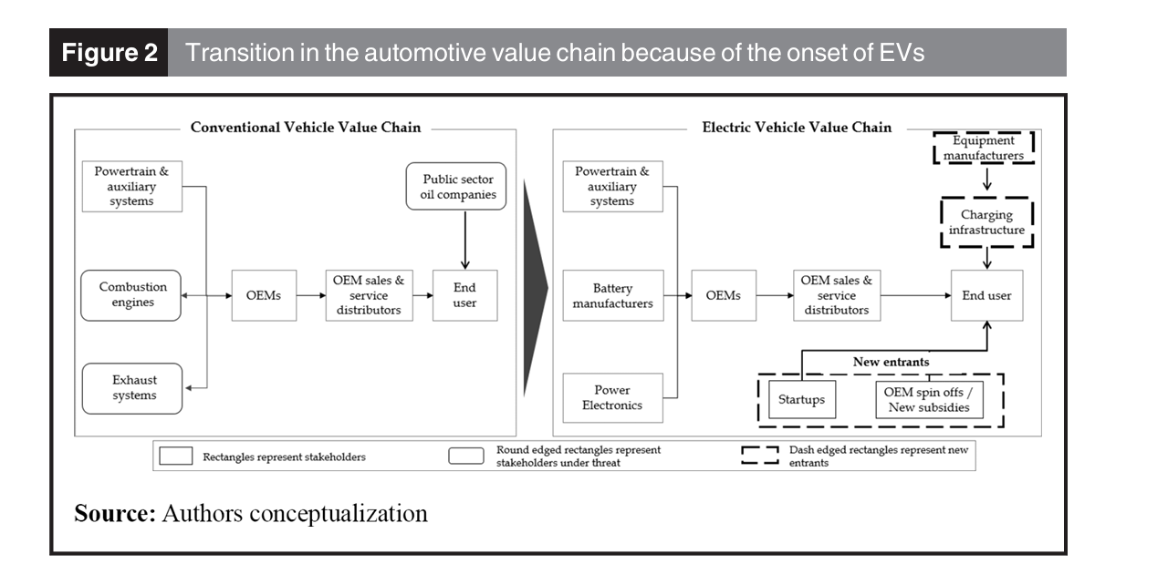

Vehicle Mishap
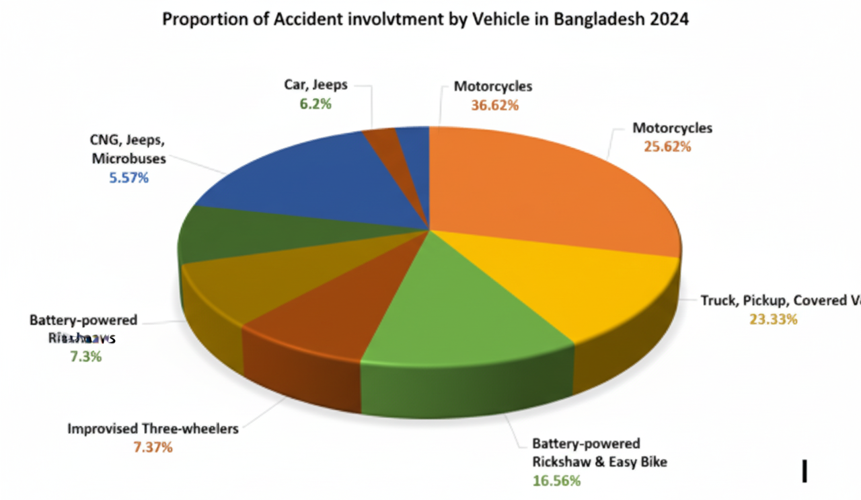
Fig: Proportion of accident by vehicle in Bangladesh 2024-25.

The figure “Proportion of Accidents by Vehicle in Bangladesh (2024–25)” highlights how different vehicles contributed to road accidents, based on the Passenger Welfare Association of Bangladesh (PWAB, January 2025) report. In 2024, 8,543 people lost their lives in road accidents. Motorcycles topped the list with 36.62% of total accidents, showing the risks from their rapid increase and unsafe driving. In contrast, CNG auto-rickshaws (5.57%) and cars/microbuses (6.21%) had the lowest accident rates. A key point is the rise of battery-powered rickshaws and easy bikes (16.56%), which now cause a large share of accidents despite being low-speed vehicles. This indicates growing safety and regulation challenges linked to Bangladesh’s fast EV adoption. The expansion of battery-powered vehicles (BPVs) — though eco-friendly and cost-effective — brings concerns about driver training, load management, and road safety. In summary, the chart reflects both the positive trend toward electric mobility and the urgent need for structured policy and safety integration to ensure sustainable EV growth in Bangladesh.

Source/Ref:
New Age | 8,543 people killed in road accidents in Bangladesh in 2024: report

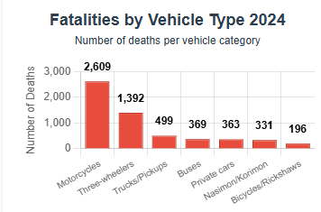
Fig: Number of deaths per vehicle category.

The chart, based on the Road Safety Foundation Report (January 2025), shows a clear picture of how different vehicles contributed to road deaths in Bangladesh. In 2024, there were 7,294 deaths and 12,019 injuries from 6,927 road accidents. The highest fatalities came from motorcycles (35.76%), highlighting their growing use and vulnerability due to poor safety measures and speeding. Three-wheelers, including battery-powered rickshaws and easy bikes, ranked second with 19.08% of deaths, showing that even low-speed vehicles can be deadly in mixed traffic conditions. Heavy vehicles like trucks and pickups (6.84%) and buses (5.05%) followed, often linked to reckless driving and road congestion. On the lower end, bicycles and manual rickshaws (2.68%) showed fewer deaths but remain common among low-income commuters. Overall, the chart underlines a serious road safety crisis, especially with the rise of electric and battery-powered vehicles (BPVs) in urban and semi-urban areas. As Bangladesh shifts toward EV adoption, ensuring driver training, safe road infrastructure, and regulation is vital to reduce fatalities and promote sustainable mobility.

Source/Ref:
Road Safety Foundation (January 2025)
Bangladesh witnessed 7,294 deaths and 12,019 injuries from 6,927 road accidents in 2024.
SRC: Bangladesh witnessed 7,294 road accident deaths in 2024: Report | Prothom Alo

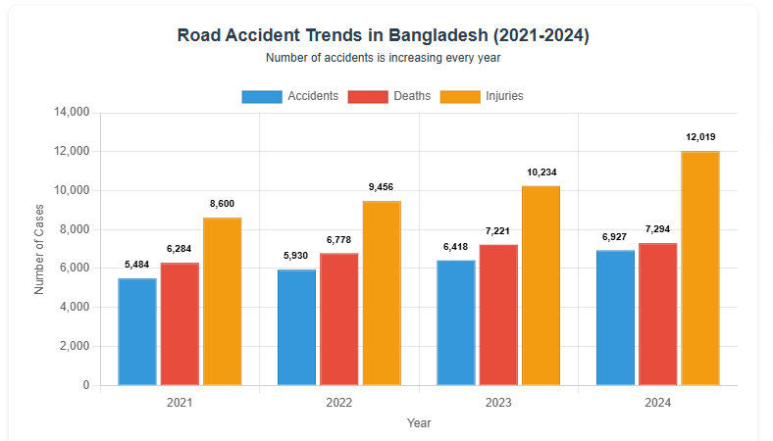
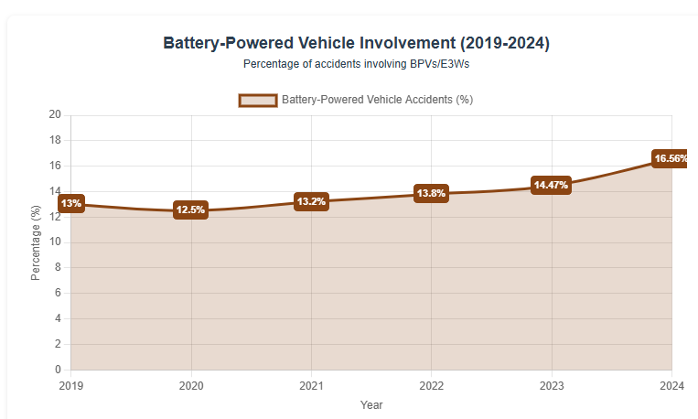
The chart “Battery-Powered Vehicle Involvement (2019–2024)” shows the gradual rise in road accidents involving battery-powered vehicles (BPVs) and electric three-wheelers (E3Ws) in Bangladesh. Over six years, the percentage increased from 13% in 2019 to 16.56% in 2024, marking a steady upward trend. This rise reflects the rapid growth in the number of easy bikes and battery-run rickshaws, especially in urban and semi-urban areas where these vehicles serve as low-cost public transport. However, the increase in accident rates highlights major safety and regulatory challenges — such as lack of licensing, improper driver training, and inadequate traffic management. While BPVs contribute positively to reduced emissions and affordable mobility, their growing involvement in accidents raises concerns about infrastructure readiness and enforcement of safety standards. The trend emphasizes the urgent need for policy intervention, route regulation, and technical standardization to ensure that the shift toward electric mobility remains sustainable and safe for Bangladesh’s transportation ecosystem.

Source/Ref:

## Electric Vehicles/Battery-Powered Vehicles (EVs/BPVs/E3Ws) Data:
### 2024 Data: New Age | 8,543 people killed in road accidents in Bangladesh in 2024: report
- Battery-powered rickshaws and easy bikes were involved in 16.56% of crashes in 2024
### 2023 Data: Road accidents claim 7,902 lives in 2023 | The Business Standard
- Battery-operated rickshaws and easybikes accounted for 14.47% of vehicles involved in accidents in 2023
### Historical Context: Affordable Electric Three-Wheeler in Bangladesh: Prospects, Challenges, and Sustainable Solutions
- In 2019, 8% of fatal accidents in Dhaka district were caused by E3Ws, which was 13% for the whole country
- Approximately 1 million electric three-wheelers were operating in Bangladesh, projected to grow to 2.5 million by 2025

5. Opportunities of Battery-Powered Vehicles

Environmental Benefits
Economic Opportunities
Energy Sector Integration
Urban Transport Efficiency
Technological Innovation

6. Challenges and Barriers

Energy & Infrastructure
Regulatory
Battery & Waste Management
Economic
Social & Safety Concerns

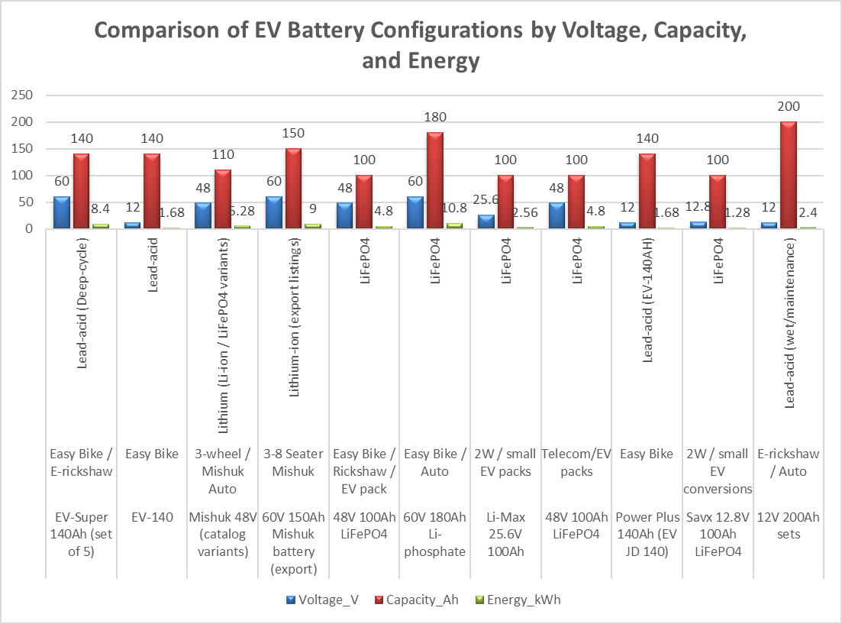

Fig: EV Battery Specs & Trends – BD 2025
Electric Vehicle Battery Configuration-figure represents a diverse scenario based on voltage, power, chemistry and costing. Lead-Acid batteries are prioritized and remains in the first-layered E-Rickshaw for their affordable price, where the price range starts from 12,000 BDT. Yet they provide limited energy(1.68kWh) and short lifespan (300-600 cycles). On the other hand, Li-based batteries specially LiFePO₄ gained the attraction for high energy density, long life-cycle (~4000 cycle). Although the higher price can be reached at 2,00,000 BDT. 12V to 60V energy output ranging from 1.28kWh to 10.8kWh offered by HyperEnergyBD's 60V 180Ah pack. 48V 110Ah Li-battery stands as a balanced alternative, of Electric Three Wheelers(E3Ws)/Mishuk, which combines sustainability and moderate price with 5.28 kWh of energy. Moreover Savx, Liwatt and Sako brands are launching specialized LiFePO₄ packs made for small Electric Vehicles and two-wheelers. It expanding the range of applications beyond typical rickshaws. Finally, the market reflects the gradual changes towards Li-technology driven by performance, longevity and growing EV demand.

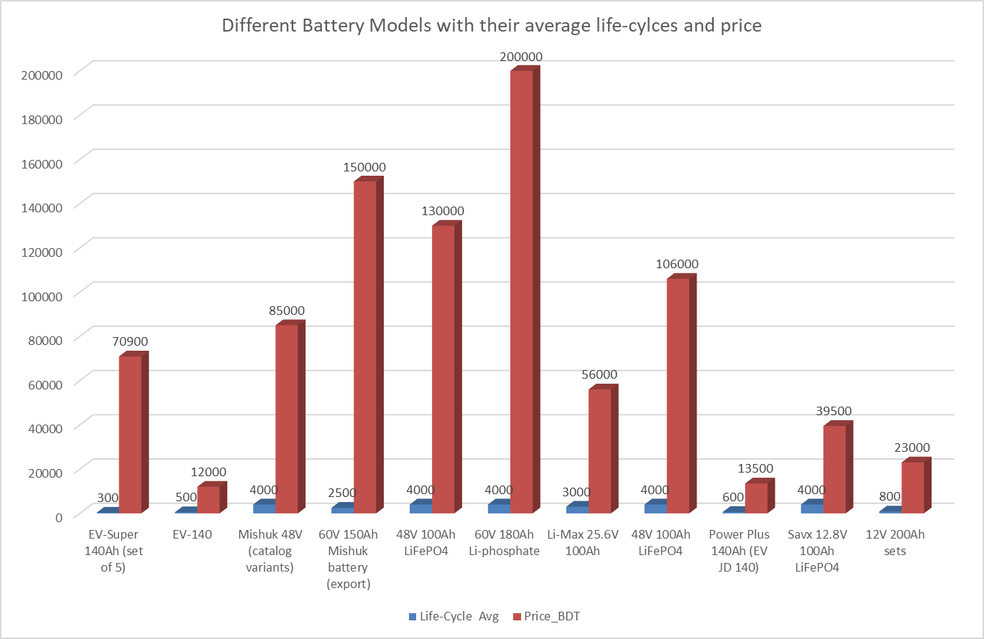

Figure: EV Battery Models – Life-Cycle vs. Price Comparison
The figure titled "Different Battery Models with their Average Life-Cycles and Price" presents a comparative analysis of electric vehicle battery alternates and also it highlights the key trade-offs between costs and longevity. On the top, 60V 180Ah LiFePO₄ battery of HeperEnergyBD has a lifespan of 4000 life cycles and the price of 2,00,000 BDT, which make it ideal for high-performance EVs. Same as, Savx, Liwatt and GreenTiger offer LiFePO₄ variants with 4000-cycle durability and the price ranging from 85000 to 1,30,000 BDT. They balance longevity and affordability. In contrast, the Hamco EV-140 and Power Plus 140Ah lead-acid models are the most budget-friendly, which priced around 12,000 to 13,500 BDT but they offer only 500-600 cycles. They are suitable for short-term use. Generic 12V 200Ah lead acid set offers a moderate price at 23,000 BDT with 800 cycles. Export-grade lithium options like Alibaba's 60V 150Ah pack offer 2500 cycles at 150,000 BDT, which reflects international standards. It is remarkable that, Saco Li-Max 25.6V 100Ah delivers 3000 cycles for just 56,000 BDT. This makes it an affordable lithium choice for small EVs. In fact, the figure represents a clear trend of: LiFePO₄ battery dominates in terms of durability, while lead-acid remains the low-cost option. Mid-range Li-battery models offer the best balance for the growing demands of Electric Vehicle demand.

Source/Ref :

https://kotharakhi.com/product-tag/navana-easy-bike-battery-price-in-bangladesh/;%20https:/navana-battery.com/electric-vehicle-ev-easy-bike-battery/https://kotharakhi.com/product/navana-ev-140ah-battery-price-in-bangladesh/
https://www.bdstall.com/details/hamko-ev-140-140ah-easy-bike-battery-77355/
https://www.alibaba.com/product-detail/Low-Price-5-8-Seater-Mishuk_1601440331513.html
https://www.alibaba.com/product-detail/5-8-Seater-Mishuk-Auto-Rickshaw_1601439908761.html
https://bme.com.bd/savx-48v-100ah-lithium-battery
https://www.hyperenergybd.com/product/60v-180ah-lithium-phosphate-battery-for-easy-bike-auto/
https://ipshatbazar.com/products/809228
https://solarsystembd.com/shop/battery/liwatt-lithium-ion-battery-48v-100-ah-telecom/
https://kotharakhi.com/product/power-plus-140-ah-easy-bike-battery-price-in-bangladesh/
https://bme.com.bd/savx-12v-100ah-lifep04-lithium-battery
https://kotharakhi.com/product/voltex-200ah-ips-battery-price-in-bangladesh/

Table 5: Framework for Managing and Reducing Challenges of Battery-Powered Electric Vehicles in Bangladesh
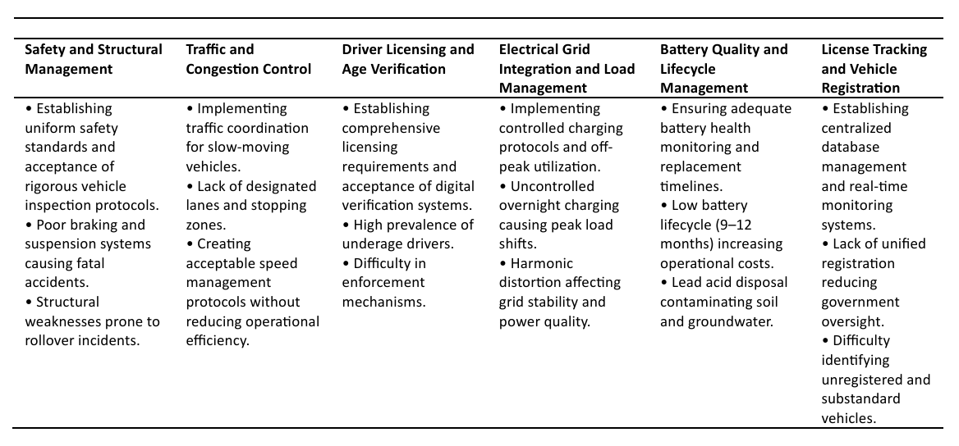

Table 5: Framework for Managing and Reducing Challenges of Battery-Powered Electric Vehicles in Bangladesh
Safety and Structural Management | Traffic and Congestion Control | Driver Licensing and Age Verification | Electrical Grid Integration and Load Management | Battery Quality and Lifecycle Management | License Tracking and Vehicle Registration
• Safety standards, vehicle inspection  • Braking issues, suspension faults  • Structural integrity, rollover risk | • Traffic coordination, lane zoning  • Speed management, slow vehicle flow  • Stopping zones, traffic flow | • Licensing requirements, digital verification  • Underage drivers, enforcement gaps  • Verification systems, licensing gaps. | • Controlled charging, off-peak usage.  • Peak load shifts, grid distortion.  • Harmonics, power quality. | • Battery health, lifecycle, disposal.  • Short lifespan, cost impact.  • Lead-acid contamination. | • Centralized database, registration, monitoring.  • Unregistered vehicles, oversight challenges.  • Substandard vehicle tracking

The table highlights six key indicator and management areas needed to manage the rapid growth of Electric Vehicles (EVs) in Bangladesh. Under safety and structural management, the importance is on implementing uniform safety standards. It addresses mechanical defects such as poor braking and rollover hazards which cause fatal accidents. Traffic and congestion control highlights the need for specific lane and speed protocols to prevent traffic congestions occurred by slow-moving Electric Vehicles. Driver licensing, strict protocols and age verification can make stops or slow down of premature or underage driver expansions. Integration of electric grid focuses on the uncontrolled charging risk. Battery quality and life span management can address environmental risks. At last finally the government should focus on license tracking, vehicle registration, low quality vehicle identification, real time observation. Along with these categories reflect the secure, need for coordinated policy reforming, efficient and sustainable EV adoption.

7. Comparative and Regional Perspective

Comparison with neighboring countries
Regional variations within Bangladesh

8. Emerging Scopes and Future Directions

9. Challenges and Possible Solutions

10. Policy Recommendations

11. Conclusion

